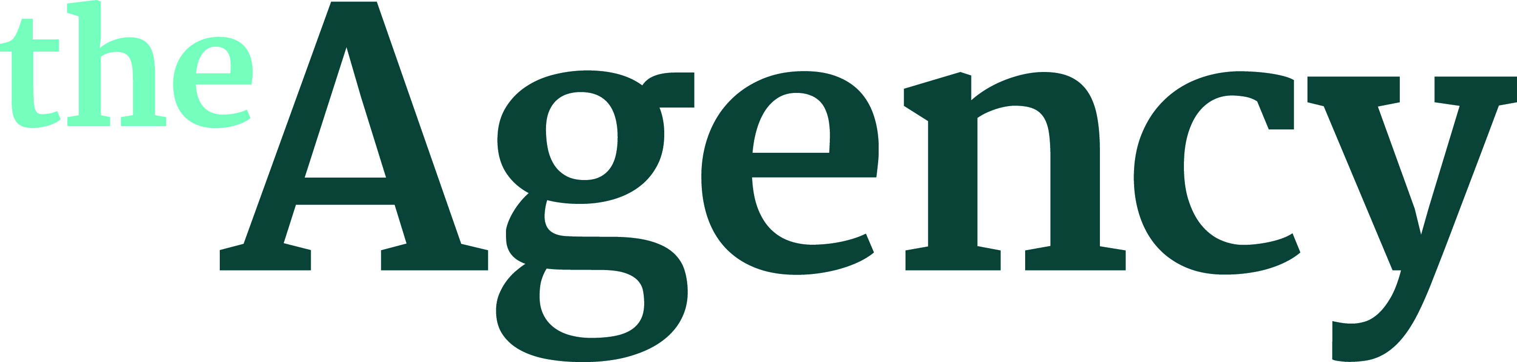

Mark Gill
Director

After winning an RTS Student Award with his graduation film Mark began production on THE VOORMAN PROBLEM, a whimsical dark comedy starring Martin Freeman and Tom Hollander. The film achieved over 50 official selections including at the Aspen ShortFest, Brussels, Rhode Island, the BFI London Film Festival, as well as a BAFTA and Oscar nomination.

Mark was selected to participate in the 2013 Screen Yorkshire Triangle feature film development scheme.

Filmography

THE BROADCAST In Development
Feature Film adaptation of the James Smythe novel 'The Testimony'
Co-Writer / Director
Riverstone / Honlodge

ENGLAND IS MINE Released 4th August 2017
Feature Film
A portrait of Morrissey as a young man
Honlodge Productions
Sales Agents: Hanway Select
UK Distribution: EOne

ZERO David Victori / Michael Fassbender Project
Additional Content Director
YouTube & Lifeboat Productions

FULL TIME 15’ Short drama
A man returns to his childhood home in the north of England to accompany his father to one last trip to the football.
Winner - Grand Short Prize - Shanghai International Film Festival 2014
Winner - Best Actor - Shanghai International Film Festival 2014
Winner - Best Made in Manchester - Kino MIFF 2014

THE VOORMAN PROBLEM 13’ Short Drama
Voorman is a prisoner who believes he is a god...
OSCAR© nomination - 2014
BAFTA© nomination - 2013
8 Short Film Awards & 50+ official festival selections Worldwide

THE BLOOMSBURY CELLARMEN Short Documentary
Winner of the Royal Television Society Student Award 2007

Member, Academy of Motion Picture Arts and Sciences

Agent: Simon Blakey at The Agency (London) Ltd
sblakey@theagency.co.uk

