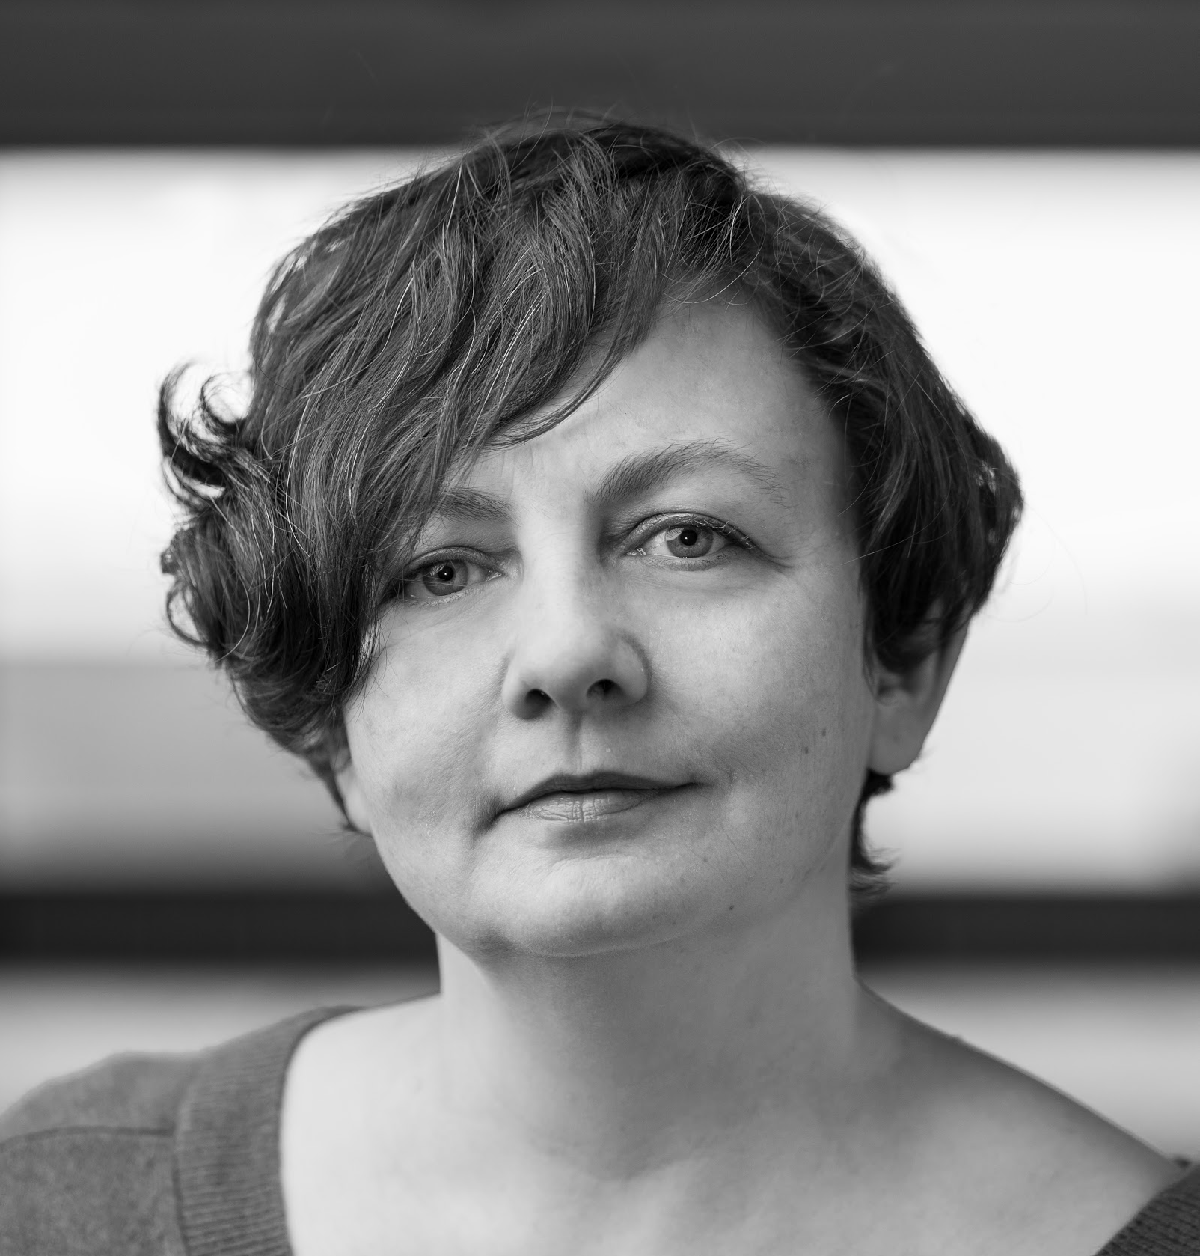
Caitríona McLaughlin
Director
Caitríona is a Theatre and Opera director from Donegal and divides her time between London and Dublin and was made an Associate Director at The Abbey Theatre in 2017. Credits there include City Song – Dylan Coburn Gray, Abbey Theatre & Soho Theatre London, 2019, On Raftery’s Hill – Marina Carr, for which she won ITTA Best Director in 2019, Two Pints by Roddy Doyle 2017, Josephine K & The Algorithms by Stacey Gregg 2017 and Monsters Dinosaurs Ghots by Jimmy McAleavey 2015.
Work in 2020 includes Mozart’s, Abduction from the Seraglio for INO and The Boy, by Marina Carr for The Abbey Theatre.

Other credits include work throughout Ireland the UK and the US; This Hostel Life, by Evangelia Rigaki's based on stories by Melatu Uche Okorie, Foyle Punt by The Local Group, Autumn Royal by Kevin Barry, Luck Just Kissed you Hello by Amy Conroy, Irish Blood English Heart by Darren Murphy, The Wild Duck by Ibsen, Judgement Day by Oden Von Hovarth, Bottom of the World and Killers and Other Family by Lucy Thurber, (both in New York), Riders to the Sea and A Dinner Engagement for Wexford Opera, Pamplemousse NI Opera. She was awarded a Clore Fellowship in 2007 and spent time on secondment to the Royal Court Theatre in 2008/09. During her time there Caitriona developed her dramaturgical skills through artistic script meetings. Having a particular interest in new writing and development she facilitated the inauguration of the Royal Court’s Theatre Local project.

