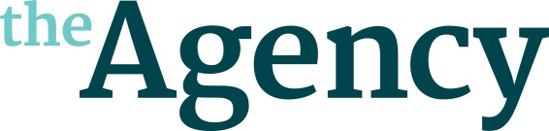

BRYCE HART

Bryce is a TV and radio comedy writer. He was named on the BBC New Talent Hotlist for 2017 and the following year was one of four writers selected to take part in the BBC Writersroom’s first ever Scottish Comedy Writing Programme.
Other work includes, Scot Squad (BBC One Scotland), Soft Border Patrol (BBC One Northern Ireland), Tourist Trap (BBC One Wales), Class Dismissed (CBBC) and Ayres on the Air (BBC Radio 4).
He was also one of eight writers shortlisted for series three of BBC Three’s original drama series The Break and his project, Sandcastle, was commissioned to script.

TERMINAL 2 (Yellow Door Productions) Currently in development
Original 30’ comedy-drama

BEEP (Happy Tramp North/BBC) Currently in development.
Producers: Neil Webster and Alison Marlow
Original sitcom about the family of a man in a long-term coma.

MARTHA’S GARDEN Currently in development
Original 30’ comedy-drama

WINGING IT (BBC Radio Scotland)
Producer: Angela Galvin
Commissioned pilot for Radio Scotland.
A sitcom following Clare and Paul Montford, two parents out of their depth with the day-to-day realities of raising a child. Broadcast scheduled for April/May 2019.

