Agent: Simon Blakey
sblakey@theagency.co.uk
+44 (0)20 7727 1346
Assistant: Seán Butler
sbutler@theagency.co.uk

Gino Green
Video & Projection Designer

Gino is a Director and Video/Projection designer whose most recent work includes SWEAT at The Donmar Warehouse & West End. He is co-founder of Black Apron Entertainment with director Lynette Linton.

Website: https://gricg.co.uk/

Theatre:

Anthem
Millennium Centre Wales
Video Designer
July 2022

That Is Not Who I Am
Royal Court Theatre
Video Designer
June 2022 - July 2022

Kabul Goes Pop: Music Television Afghanistan
Brixton House
Video Designer
May 2022 - June 2o22

Get Up Stand Up! The Bob Marley Musical
Lyric Theatre Shaftesbury Avenue
Associate Video Designer
October 2021 - Present

Small Island (Revival)
National Theatre
Associate Projection Designer
February 2022 - April 2022

Anthem
Wales Millennium Centre
Video Designer

Get Up Stand Up! The Bob Marley Musical
Lyric Theatre Shaftesbury Avenue
Associate Video Designer
October 2021 - Present

Edge
National Youth Theatre
Commissioned for Cop26
Video Designer

Lava
Bush Theatre
Projection Designer
June 2021 - July 2021

Children’s Children
English Touring Theatre
Director of Photography/ Editor
Jan 2021 - Feb 2021

Beyond The Canon
RADA
Video Designer
Sept 2020 - Oct 2020

Poor Connection
RADA – Online Project
Video Designer
June 2020 - August 2020

Be More Chill
Mark Rubenstein Limited - The Other Palace
Associate Projection Designer
January 2020 - February 2020

You Are the Champions Campaign
Queen - Online
Videographer
July 2019

Sweat
Mark Rubenstein Limited - Gielgud Theatre
Dir: Lynette Linton
Video/Projection Designer (West End Transfer)
May - June 2019

★★★★★
The Observer, The Guardian, Financial Times,
Daily Telegraph, Evening Standard, Time Out

Small Island
National Theatre
Associate Projection Designer
January 2019 - April 2019
Nominated for What’sOnStage Best Video Design

Passages: A Windrush Celebration
Black Apron Entertainment - Royal Court
Video Designer/Director/Assistant Director/Editor
December 2018 - April 2019

Sweat
Donmar Warehouse
Dir: Lynette Linton
Video Designer
October 2018 - December 2018

Hashtag Lightie
Arcola Theatre
Video Designer/Assistant Director
January 2017 - March 2017 & October 2017 - December 2017

Lightie
Gate Theatre
Projection Designer
January 2016

© Copyright The Agency (London) Ltd. 2021

Not to be reproduced in any form without permission of the Copyright holder.

LAVA
Bush Theatre 2021

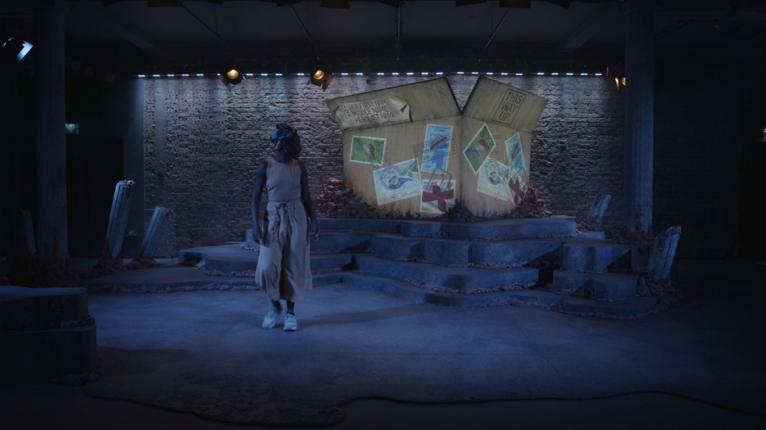

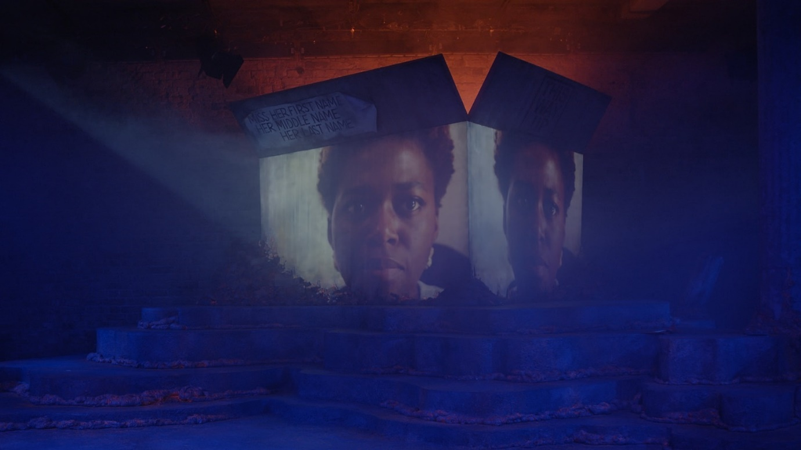

SWEAT
Donmar Warehouse & West End

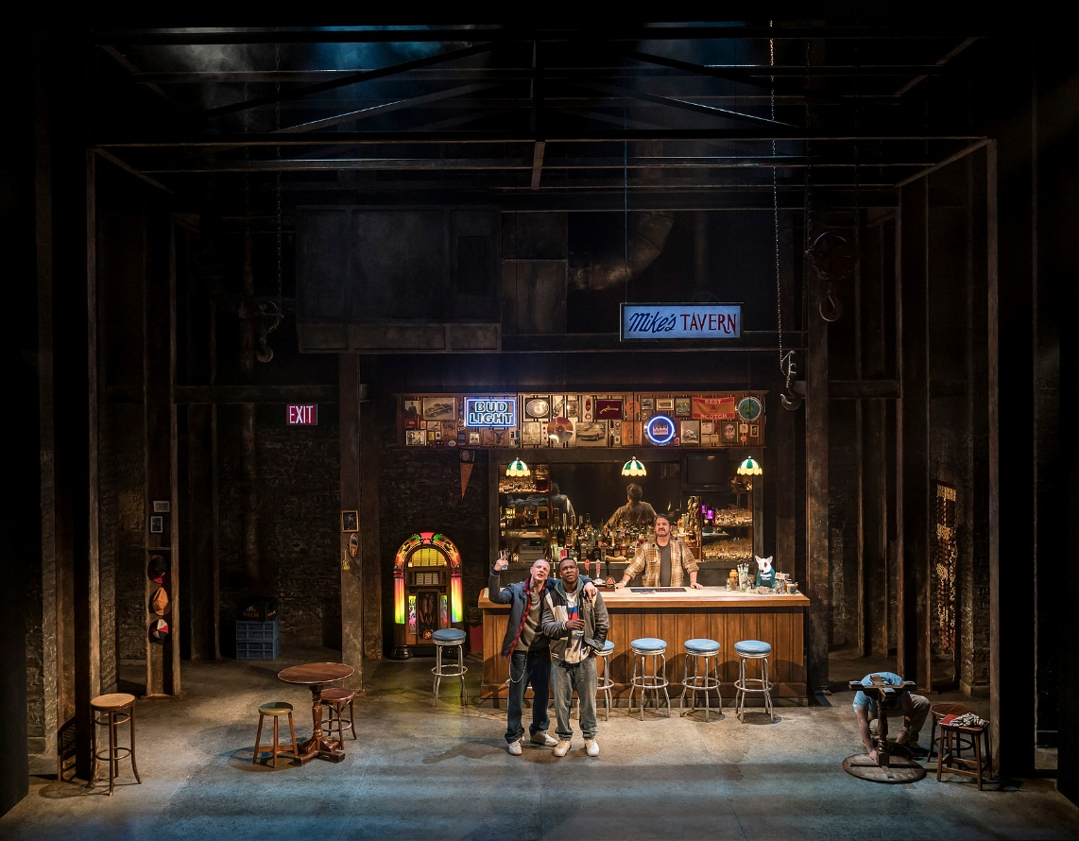

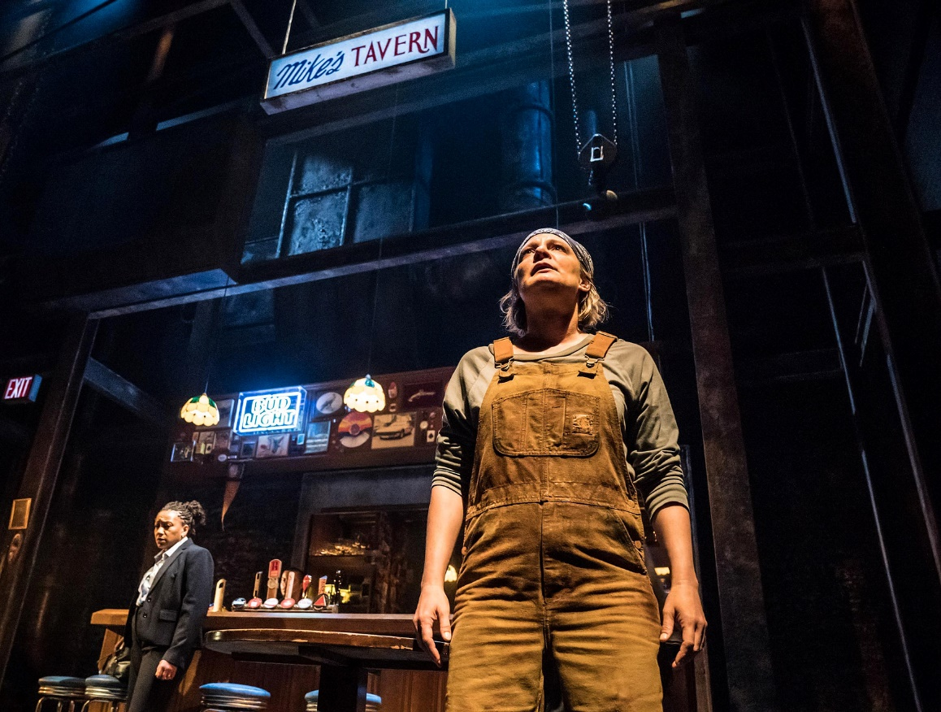

SMALL ISLAND
National Theatre
(Associate)

