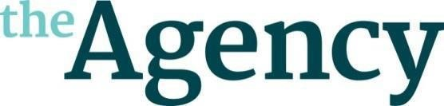
Arwen Roberts

Agent Sophie Kelleher (skelleher@theagency.co.uk)

Arwen is a screenwriter and freelance script editor, originally from Hull. She began her career in television working with the BBC Drama department – and has since held various positions within production and editorial teams for Hat Trick Productions, Eleven Film, Carnival Films, the BBC and Sky.

Arwen has worked with top-tier showrunners and exciting new talent alike, including Nicole Taylor, Bill Gallagher, Sarah Farinha, Nathaniel Price, Helen Edmundson and Grace Ofori-Attah. She thrives in a dynamic writersroom environment, with vast experience in both serialised and story of the week narratives on shows such as BELGRAVIA, OUR GIRL and JAMESTOWN.

As a writer, Arwen takes inspiration from modern short stories, reality TV, cult documentary and social media and is currently developing a variety of projects that explore class, gender, and the knotty reality of human psychology in heightened genre pieces; delivering compelling world building, and narratives that are both exhilarating and resonant.
Arwen has a degree in English Language and Media from the University of Brighton and has taken part in a creative writing course in her hometown with Hull Truck theatre.

© Copyright The Agency (London) Ltd. 2023
Not to be reproduced in any form without permission of the Copyright holder.

